Comparison of the Efficacy of Empagliflozin and Dapagliflozin in Reducing Proteinuria in Patients with Type 2 Diabetes Mellitus: A Randomized Controlled Trial
Bilal Javaid, Ijaz Nabi, Muhammad Irfan, Mujahid Iqbal, Madiha Rauf, Salman Mehmood
Allied Hospital Faisalabad Medical University, Faisalabad
Abstract
Objectives: To compare the efficacy of empagliflozin and dapagliflozin in reducing proteinuria among patients with type 2 diabetes mellitus (T2DM)
Methods: This randomized controlled trial was conducted in the Department of Nephrology, Allied Hospital-I, Faisalabad, Pakistan, from February 29, 2024, to August 28, 2024. One hundred adult patients with T2DM and proteinuria who fulfilled the eligibility criteria were enrolled and randomly allocated into two equal groups. Group A received empagliflozin 25 mg once daily, whereas Group B received dapagliflozin 10 mg once daily for 12 weeks. Twenty-four-hour urinary protein was measured at baseline and after 12 weeks of treatment. The primary outcome was a ≥30% reduction in 24-hour urinary protein from baseline.
Results: The mean age of participants was 47.43 ± 9.31 years. Sixty patients (60%) were aged 30–50 years, and 40 (40%) were aged 51–75 years. Overall, 21 patients (21%) were male and 79 (79%) were female. Clinical efficacy was achieved in 46 of 50 patients (92.0%) receiving empagliflozin compared with 38 of 50 patients (76.0%) receiving dapagliflozin. Empagliflozin demonstrated significantly greater efficacy in reducing proteinuria than dapagliflozin (p = 0.029).
Conclusion: Empagliflozin was significantly more effective than dapagliflozin in reducing proteinuria among patients with type 2 diabetes mellitus after 12 weeks of treatment. Larger multicenter studies with longer follow-up are required to confirm these findings and determine whether the greater reduction in proteinuria translates into improved long-term renal outcomes.
Keywords: Type 2 diabetes mellitus, Proteinuria, Empagliflozin, Dapagliflozin, Diabetic kidney disease.
How to cite this:
Javaid B, Nabi I, Irfan M, Iqbal M, Rauf M, Mehmood S. Comparison of the Efficacy of Empagliflozin and Dapagliflozin in Reducing Proteinuria in Patients with Type 2 Diabetes Mellitus: A Randomized Controlled Trial. J Pak Soc Intern Med. 2026;7(3):
Corresponding Author: Dr. Bilal Javaid Email: dr.bilaljavaid160@gmail.com
Received: 12-01-2026 Revised: 13-05-2026 Accepted: 12-08-2026
DOI: https://doi.org/10.70302/jpsim.v7i3.2642

Introduction
Type 2 diabetes mellitus (T2DM) is the leading cause of chronic kidney disease (CKD) worldwide and remains a major contributor to end-stage kidney disease (ESKD). Persistent proteinuria is one of the earliest clinical manifestations of diabetic kidney disease (DKD) and is independently associated with accelerated decline in renal function, increased cardiovascular morbidity, and premature mortality. Therefore, reduction of proteinuria has become a key therapeutic target in the management of patients with diabetic kidney disease.¹⁻⁴
Sodium–glucose cotransporter-2 (SGLT2) inhibitors have emerged as an important class of glucose-lowering agents with substantial cardiovascular and renal benefits that extend beyond glycaemic control. By inhibiting glucose and sodium reabsorption in the proximal renal tubules, these agents restore tubuloglomerular feedback, reduce intraglomerular hypertension, decrease albuminuria, and slow the progression of chronic kidney disease.⁴⁻⁶
Large randomized controlled trials have consistently demonstrated the renoprotective effects of SGLT2 inhibitors. The EMPA-REG OUTCOME trial first showed that empagliflozin significantly reduced progression of kidney disease and albuminuria in patients with T2DM and established cardiovascular disease.⁵ Subsequently, the DAPA-CKD trial demonstrated that dapagliflozin significantly reduced the risk of sustained decline in estimated glomerular filtration rate (eGFR), end-stage kidney disease, and renal or cardiovascular death in patients with chronic kidney disease, irrespective of diabetes status.¹⁶⁷ More recently, the EMPA-KIDNEY trial further confirmed that empagliflozin reduced the risk of kidney disease progression or cardiovascular death across a broad spectrum of patients with chronic kidney disease.⁸
Among currently available SGLT2 inhibitors, empagliflozin and dapagliflozin are the most widely prescribed agents. Although both drugs have demonstrated significant renoprotective effects in placebo-controlled trials, direct comparative evidence evaluating their relative efficacy in reducing proteinuria remains limited. Most published studies have compared individual SGLT2 inhibitors with placebo rather than directly comparing one agent with another.^{9,10}
Furthermore, evidence from South Asian populations, particularly Pakistan, remains scarce. Differences in genetic background, environmental factors, healthcare access, and disease characteristics may influence treatment response; therefore, locally generated evidence is essential to guide clinical practice. To date, only limited regional data have evaluated the antiproteinuric effects of SGLT2 inhibitors in Pakistani patients with T2DM.¹¹
The present randomized controlled trial was therefore conducted to compare the efficacy of empagliflozin and dapagliflozin in reducing proteinuria among patients with T2DM attending a tertiary care hospital in Pakistan. The findings are expected to provide locally relevant evidence that may assist clinicians in selecting the most effective SGLT2 inhibitor for reducing proteinuria in patients with diabetic kidney disease.
Methods
This randomized controlled trial was conducted in the Department of Nephrology, Allied Hospital-I, Faisalabad, Pakistan, from 29 February 2024 to 28 August 2024. The study protocol was approved by the Institutional Ethical Review Committee of Faisalabad Medical University before participant recruitment. Written informed consent was obtained from all participants before enrolment.
A total of 100 patients with type 2 diabetes mellitus (T2DM) and proteinuria were enrolled using a consecutive sampling technique and were randomly allocated in a 1:1 ratio into two treatment groups using the lottery method. The sample size was calculated using the WHO Sample Size Calculator, assuming a 95% confidence level, 80% study power, an expected efficacy of 79.55% in the empagliflozin group and 97.4% in the dapagliflozin group based on previous studies, resulting in a required sample size of *100 participants (50 patients per group). ^{9,10}
Eligible participants were 30–75 years of age, of either sex, had a confirmed diagnosis of T2DM, and had documented proteinuria. Patients with type 1 diabetes mellitus, pregnancy, active malignancy, severe hepatic disease, advanced renal impairment requiring renal replacement therapy, or known hypersensitivity to either study medication were excluded. In addition, patients receiving angiotensin-converting enzyme inhibitors (ACEIs), angiotensin receptor blockers (ARBs), glucagon-like peptide-1 receptor agonists (GLP-1 RAs), or other medications known to significantly influence urinary protein excretion were excluded to minimize potential confounding.
Participants assigned to Group A received empagliflozin 25 mg orally once daily, whereas those assigned to Group B received dapagliflozin 10 mg orally once daily for 12 weeks. Medication adherence was assessed through weekly follow-up visits, during which used and unused tablet strips were counted. Participants were encouraged to maintain their usual dietary habits and standard diabetes care throughout the study period.
The primary outcome measure was the change in 24-hour urinary protein excretion after 12 weeks of treatment. Twenty-four-hour urinary protein was measured at baseline and at the completion of the treatment period using the hospital laboratory's standardized analytical methods. Treatment efficacy was defined a priori as a ≥30% reduction in 24-hour urinary protein excretion from baseline after 12 weeks of therapy.
Demographic and clinical data, including age, sex, duration of diabetes mellitus, body mass index (BMI), and urinary protein measurements, were recorded using a standardized data collection form. Data were entered and analyzed using IBM SPSS Statistics for Windows, Version 25.0 (IBM Corp., Armonk, NY, USA). Continuous variables are presented as mean ± standard deviation (SD), whereas categorical variables are expressed as frequency and percentage. Baseline characteristics were compared descriptively between the two groups. The Chi-square test was used to compare treatment efficacy between groups. A two-sided p-value <0.05 was considered statistically significant.
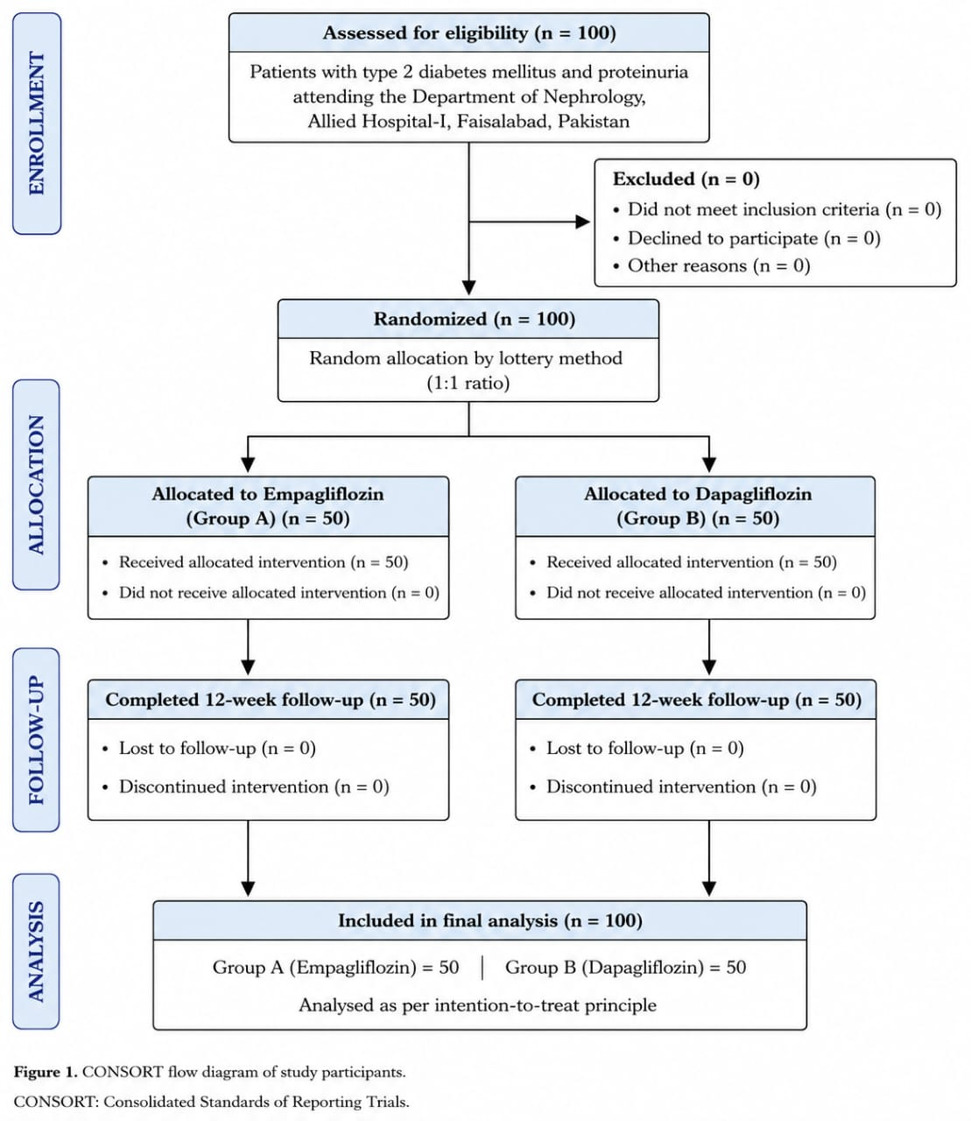
Figure 1. CONSORT flow diagram of study participants

Results
A total of 100 patients with type 2 diabetes mellitus were enrolled and randomized equally into two treatment groups. Group A (n = 50) received empagliflozin, whereas Group B (n = 50) received dapagliflozin. All participants completed the 12-week follow-up and were included in the final analysis.
The mean age of the study population was 47.43 ± 9.31 years. Patients in the empagliflozin group had a mean age of 47.32 ± 9.67 years, while those in the dapagliflozin group had a mean age of 47.00 ± 9.28 years. Sixty participants (60.0%) were between 30 and 50 years of age, whereas forty (40.0%) were between 51 and 75 years (Table I).
Of the 100 participants, 21 (21.0%) were male and 79 (79.0%) were female. Group A comprised of 12 males (24.0%) and 38 females (76.0%), whereas Group B included 9 males (18.0%) and 41 females (82.0%) (Table II).
The overall mean duration of diabetes mellitus was 6.94 ± 2.12 years. The mean duration was 6.88 ± 2.09 years in the empagliflozin group and 7.00 ± 2.14 years in the dapagliflozin group. Forty patients (40.0%) had diabetes for ≤6 years, while sixty (60.0%) had a disease duration of >6 years (Table III).
The overall mean body mass index (BMI) was 26.17 ± 3.11 kg/m². The mean BMI was 26.08 ± 2.95 kg/m² in Group A and 26.26 ± 3.26 kg/m² in Group B. Fifty-two participants (52.0%) had a BMI of ≤25 kg/m², whereas forty-eight (48.0%) had a BMI of >25 kg/m² (Table I).
After 12 weeks of treatment, 46 of 50 patients (92.0%) in the empagliflozin group achieved the predefined efficacy outcome (≥30% reduction in 24-hour urinary protein excretion), compared with 38 of 50 patients (76.0%) in the dapagliflozin group. Conversely, treatment was ineffective in 4 patients (8.0%) receiving empagliflozin and 12 patients (24.0%) receiving dapagliflozin.
The difference in treatment efficacy between the two groups was statistically significant (χ² test, p = 0.029) (Table II), indicating that empagliflozin produced a significantly greater reduction in proteinuria than dapagliflozin after 12 weeks of therapy.

Table I. Baseline characteristics of the study participants (N = 100).
Characteristic | Empagliflozin  Group A (n=50) | Dapagliflozin  Group B (n=50) | Total  (N=100) | P-value*
Age (years)
Mean ± SD | 47.32 ± 9.67 | 47.00 ± 9.28 | 47.43 ± 9.31 | 0.87
• 30–50 years, n (%) | 29 (58.0) | 31 (62.0) | 60 (60.0) | 0.69†
• 51–75 years, n (%) | 21 (42.0) | 19 (38.0) | 40 (40.0)
Gender, n (%)
• Male | 12 (24.0) | 9 (18.0) | 21 (21.0) | 0.46†
• Female | 38 (76.0) | 41 (82.0) | 79 (79.0)
Duration of diabetes (years)
Mean ± SD | 6.88 ± 2.09 | 7.00 ± 2.14 | 6.94 ± 2.12 | 0.78
• ≤6 years, n (%) | 20 (40.0) | 20 (40.0) | 40 (40.0) | 1.00†
• >6 years, n (%) | 30 (60.0) | 30 (60.0) | 60 (60.0)
BMI (kg/m²)
Mean ± SD | 26.08 ± 2.95 | 26.26 ± 3.26 | 26.13 ± 3.19 | 0.77
• ≤25 kg/m², n (%) | 25 (50.0) | 27 (54.0) | 52 (52.0) | 0.67†
• >25 kg/m², n (%) | 25 (60.0) | 23 (66.0) | 48 (48.0)
Values are presented as mean ± standard deviation (SD) or number (%). * P-values compare baseline characteristics between groups. Student’s t-test for continuous variables; Chi-square test for categorical variables (†).
Table II. Comparison of the efficacy of Dapagliflozin and Empagliflozin in terms of lowering proteinuria in type 2 Diabetes Mellitus.
 | Group A (n=50) |  | Group B (n=50)
 | No. of Patients | %age | No. of Patients | %age
EFFICIENCY | Yes | 46 | 92.0 | 38 | 76.0
EFFICIENCY | No | 04 | 8.0 | 12 | 24.0
P-value = 0.0291 which is statistically significant.

Discussion
The present randomized controlled trial compared the efficacy of empagliflozin and dapagliflozin in reducing proteinuria among patients with type 2 diabetes mellitus. Baseline demographic and clinical characteristics, including age, sex, duration of diabetes, and body mass index, were comparable between the two treatment groups, thereby minimizing the likelihood that baseline differences influenced the observed treatment outcomes.
The principal finding of this study was that empagliflozin demonstrated significantly greater efficacy than dapagliflozin in reducing proteinuria after 12 weeks of treatment. Clinical efficacy, defined as a ≥30% reduction in 24-hour urinary protein excretion, was achieved in 92.0% of patients receiving empagliflozin compared with 76.0% of those receiving dapagliflozin (p = 0.029). These findings suggest that although both SGLT2 inhibitors are effective in reducing proteinuria, empagliflozin may provide greater short-term antiproteinuric benefit in patients with T2DM.
The renoprotective effects of SGLT2 inhibitors have been consistently demonstrated in large multicentre randomized controlled trials. The EMPA-REG OUTCOME trial first established that empagliflozin significantly reduced progression to macroalbuminuria, slowed deterioration of renal function, and decreased clinically relevant renal outcomes in patients with T2DM and established cardiovascular disease.¹³ Subsequently, the DAPA-CKD trial demonstrated that dapagliflozin significantly reduced the risk of sustained decline in estimated glomerular filtration rate (eGFR), end-stage kidney disease, and renal or cardiovascular death in patients with chronic kidney disease, regardless of diabetes status.¹⁶ More recently, the EMPA-KIDNEY trial confirmed that empagliflozin reduced the risk of kidney disease progression or cardiovascular death across a broad spectrum of patients with chronic kidney disease.²² Although these landmark trials were placebo-controlled and were not designed as direct head-to-head comparisons between SGLT2 inhibitors, they provide robust evidence supporting the renoprotective effects of this therapeutic class.
The greater reduction in proteinuria observed with empagliflozin in our study is consistent with the renal benefits reported in the EMPA-REG OUTCOME trial, where empagliflozin reduced progression of albuminuria and delayed worsening of kidney function.¹¹ Our findings also complement those of the DAPA-CKD trial, confirming that both empagliflozin and dapagliflozin exert clinically meaningful antiproteinuric effects.¹² However, unlike those large multicentre studies, the present trial directly compared the two agents, thereby providing comparative evidence regarding their relative efficacy in reducing proteinuria.
Evidence from Asian populations also supports the renoprotective role of SGLT2 inhibitors. The Y-AIDA study conducted in Japanese patients with diabetic kidney disease demonstrated that dapagliflozin significantly reduced albuminuria while improving blood pressure and other renal risk markers.⁶ Tthese findings suggest that the beneficial renal effects of SGLT2 inhibitors are reproducible across different ethnic populations, although the magnitude of benefit may vary according to patient characteristics and study design.
Our findings are further supported by emerging evidence from Pakistan. A single-blind interventional study conducted at the Department of Nephrology, Combined Military Hospital (CMH), Quetta, demonstrated that empagliflozin significantly reduced proteinuria compared with placebo in patients with T2DM.¹³ Unlike the CMH study, which compared empagliflozin with placebo, the present trial directly compared empagliflozin with dapagliflozin. The superior antiproteinuric efficacy observed with empagliflozin in our cohort therefore provides clinically relevant comparative data from the local population. Nevertheless, confirmation through larger multicentre studies is required before definitive conclusions regarding superiority can be drawn.
The mechanism underlying the greater antiproteinuric effect observed with empagliflozin remains uncertain. Both empagliflozin and dapagliflozin inhibit the sodium–glucose cotransporter-2 in the proximal renal tubule, restoring tubuloglomerular feedback, reducing intraglomerular pressure, and decreasing urinary protein excretion.⁴˒⁹ Minor differences in pharmacodynamic characteristics, patient-related factors, or baseline renal physiology may have contributed to the differences observed in our study. However, the present trial was not designed to investigate mechanistic differences between the two drugs, and therefore these findings should be interpreted cautiously.
The present study has several limitations. First, it was conducted at a single tertiary care centre, which may limit the generalizability of the findings. Second, the sample size was relatively small (100 participants), reducing the statistical power to detect smaller treatment differences. Third, the follow-up period was limited to 12 weeks, precluding assessment of long-term renal outcomes. Finally, the primary endpoint was reduction in proteinuria rather than hard renal endpoints such as sustained decline in eGFR, initiation of kidney replacement therapy, end-stage kidney disease, or cardiovascular mortality.¹⁴ Future multicenter randomized controlled trials with larger sample sizes and longer follow-up are warranted to determine whether the greater reduction in proteinuria observed with empagliflozin translates into superior long-term renal outcomes.
Overall, the findings of the present study reinforce the established renoprotective role of SGLT2 inhibitors in patients with T2DM. Both empagliflozin and dapagliflozin significantly reduced proteinuria; however, empagliflozin demonstrated superior short-term antiproteinuric efficacy in this study population. These findings provide valuable local evidence and may assist clinicians in selecting appropriate SGLT2 inhibitor therapy for patients with diabetic kidney disease while highlighting the need for larger comparative trials.

Conclusion: Empagliflozin and dapagliflozin both significantly reduced proteinuria in patients with type 2 diabetes mellitus. However, empagliflozin demonstrated significantly greater short-term antiproteinuric efficacy than dapagliflozin after 12 weeks of treatment. These findings suggest that empagliflozin may be a preferred SGLT2 inhibitor for reducing proteinuria in appropriately selected patients with diabetic kidney disease. Nevertheless, larger multicenter randomized controlled trials with longer follow-up are required to determine whether this greater reduction in proteinuria translates into superior long-term renal and cardiovascular outcomes.

Ethical Approval: The IRB/EC approved this study via letter no. 48.ERC/FMU/2023-24/313 dated September 13, 2023.
Conflict of Interest: None
Funding Source: None
Authors’ Contribution
BJ: Conceptualization of the project
IN, MIr: Design of the work.
MI, MR, SM: Data acquisition, analysis, or interpretation.
MIr, MI, MR, SM: Draft the work.
BJ, IN: Critical review critically of important intellectual content.
All authors approve the version to be published.
All authors agree to be accountable for all aspects of the work.

References
- Azeem S, Khan U, Liaquat A. The increasing rate of diabetes in Pakistan: a silent killer. Ann Med Surg (Lond). 2022;79:103901.
- Abdelwahid HA, Dahlan HM, Mojemamy GM, Darraj GH. Predictors of microalbuminuria and its relationship with glycemic control among patients with type 2 diabetes mellitus. BMC Endocr Disord. 2022;22(1):1-8.
- Natesan V, Kim SJ. Diabetic nephropathy: a review of risk factors, progression, mechanism and dietary management. Biomol Ther (Seoul). 2021;29(4):365-72.
- Delanaye P, Wissing KM, Scheen AJ. Sodium-glucose cotransporter 2 inhibitors: renal outcomes according to baseline albuminuria. Clin Kidney J. 2021;14(12):2463-71.
- 5. Wanner C, Inzucchi SE, Lachin JM, Fitchett D, von Eynatten M, Mattheus M, et al. Empagliflozin and progression of kidney disease in type 2 diabetes. N Engl J Med. 2016;375(4):323-34.
- Kinguchi S, Wakui H, Ito Y, Kondo Y, Azushima K, Osada U, et al. Improved home blood pressure profile with dapagliflozin is associated with amelioration of albuminuria in Japanese patients with diabetic nephropathy: the Y-AIDA study. Cardiovasc Diabetol. 2019;18(1):1-16.
- Jin ZJ, Wang GZ. Clinical efficacy of dapagliflozin in the treatment of patients with diabetic nephropathy and its effect on proteinuria. Diabetes Metab Syndr Obes. 2023;16:2167-2175.
- Ruggenenti P, Kraus BJ, Inzucchi SE, Zinman B, Hantel S, Mattheus M, et al. Nephrotic-range proteinuria in type 2 diabetes: effects of empagliflozin on kidney disease progression and clinical outcomes. E Clin Med. 2022;43:101240.
- Zinman B, Wanner C, Lachin JM, Fitchett D, Bluhmki E, Hantel S, et al. Empagliflozin, cardiovascular outcomes, and mortality in type 2 diabetes. N Engl J Med. 2015;373(22):2117-28.
- Wiviott SD, Raz I, Bonaca MP, Mosenzon O, Kato ET, Cahn A, et al. Dapagliflozin and cardiovascular outcomes in type 2 diabetes. N Engl J Med. 2019;380(4):347-57.
- Heerspink HJL, Stefánsson BV, Correa-Rotter R, Chertow GM, Greene T, Hou FF, et al. Dapagliflozin in patients with chronic kidney disease. N Engl J Med. 2020;383(15):1436-16.
- Herrington WG, Staplin N, Wanner C, Green JB, Hauske SJ, Emberson J, et al. Empagliflozin in patients with chronic kidney disease. N Engl J Med. 2023;388(2):117-27.
- Butler J, Packer M, Siddiqi TJ, Böhm M, Brueckmann M, Januzzi JL Jr, et al. Efficacy of empagliflozin in patients with heart failure across kidney risk categories. J Am Coll Cardiol. 2023;81(19):1902-14.
- Khan Z, Altaf A, Jhanzaib S, Ijaz MU, Fazal N, Ikhlaq A. Efficacy of empagliflozin in slowing the progression of renal disease in patients with type 2 diabetes: a single-blind interventional placebo-controlled study at a tertiary care setting in Quetta. Life Sci. 2025;6(4):522-7.

