Knowledge, Perceptions and Misconceptions Regarding HPV Vaccination among Adolescent Girls in Pakistan

Fatima Khanum¹, Alssa Omer Alvi², Minahil Waheed², Anum Shahid¹, Mahatab Noor², Moeez Ali Khan³

¹Services Institute Of Medical Sciences, Lahore, ²Al- Aleem Medical College, Lahore, ³Rashid Lateef Medical College, Lahore
Abstract
Objective: To assess the knowledge, perceptions and misconceptions regarding Human Papillomavirus (HPV) infection and HPV vaccination among adolescent girls in Pakistan.
Methods: This was a cross-sectional survey-based study conducted over a defined study period in schools and community settings. Adolescents falling within the recommended age range for HPV vaccination were included. Data regarding demographic profile, awareness of HPV, knowledge of its association with cervical cancer, understanding of HPV vaccination, and perceived barriers to vaccination was collected and analyzed.
Results: A total of 633 respondents participated in the survey. The most common age was 13 years and overall awareness regarding HPV was 57%. Among the participants, 628 (99%) were females and 5 (1%) were males. Four hundred and ten (65%) participants had secondary education, 118 (19%) had no formal education, 64 (10%) had primary education and 41 (6%) had higher education. Overall, 432 (68%) participants linked HPV with cervical cancer, 505 (80%) knew that HPV vaccination is recommended for prevention of cervical cancer, and 439 (69%) knew that the vaccine prevents cervical cancer. The most common barriers to vaccination were myths and misconceptions 195 (31%), cultural concerns 192 (30%), lack of awareness 149 (24%), access issues 90 (14%) and cost 74 (12%).
Conclusion: Awareness regarding HPV and HPV vaccination among adolescent girls in Pakistan was moderate, with myths, misconceptions and cultural concerns being the major barriers to vaccination. Since the participants belonged to the adolescent age group, early educational intervention is crucial. Targeted school-based awareness programs may help reduce misconceptions, improve knowledge, and increase HPV vaccination acceptance in Pakistan.
Keywords: Human Papillomavirus, HPV vaccination, cervical cancer, adolescent girls, awareness, misconceptions, Pakistan.

How to cite this:
Khanum F, Alvi AO, Waheed M, Shahid A, Noor M, Khan MA. Knowledge, Perceptions and Misconceptions Regarding HPV Vaccination among Adolescent Girls in Pakistan. J Pak Soc Intern Med. 2026;7(3):
Corresponding Author: Dr. Anum Shahid Email: anumshahid1986@gmail.com
Received: 15-03-2026 Revised: 18-06-2026 Accepted: 12-08-2026
DOI: https://doi.org/10.70302/jpsim.v7i3.2645

Introduction

Human Papillomavirus (HPV) is the most common viral infection of the reproductive tract among females and the leading cause of cervical cancer.¹ HPV infections, in most of the cases, resolve spontaneously but some persist, causing warts and precancerous lesions, so it is implicated in the development of malignancies of the vulva, vagina, anus, penis and oropharynx.² The risk of acquiring HPV infection is high in sexually active individuals and is transmitted primarily by direct skin-to-skin genital contact.³
The global burden of HPV and cervical cancer remains considerable. According to World Health Organization (WHO), in 2022 about 660,000 new cases of cervical cancer were reported with 350,000 mortalities worldwide. Cervical cancer ranks as the fourth most common cancer in women globally, with 90% of cases observed in low- and middle-income countries (LMICs) where resources to screen and vaccinate are limited¹. The introduction of HPV vaccine served as a major breakthrough in preventing HPV-associated diseases. Two vaccines (Gardasil and Cervarix) are available worldwide for high-risk HPV-genotypes and a few are in developmental stages. The national immunization programs of various countries have incorporated the HPV vaccine in their vaccination protocol.^{4,5} WHO recommends routine HPV immunization for girls aged 9–14 years before the onset of sexual activity¹. Furthermore, vaccination strategies in several regions have been expanded to include males, recognizing the role of HPV in disease development in both sexes.⁶
In Pakistan, HPV is a significant public health concern but under-addressed. Around 5,000 women are diagnosed with the disease each year and nearly 3,000 mortalities are associated with it. At present, it is the third most common cancer among women in the country and the second most common among women aged 15–44 years. Studies also suggest that around 0.5% of women carry HPV types 16 and 18 infections at any given time, while these high-risk HPV types are responsible for 88.1% of invasive cervical cancer cases. Despite this, there is a lack of organized screening programs, widespread vaccination initiatives and structured public health programs. Socio-economic, cultural, and access-related factors are major barriers to vaccine uptake and resulted in limited awareness and understanding, leading to increased disease burden.⁷
Therefore, this study is directed to assess the knowledge, perceptions and misconceptions of adolescent girls in Pakistan regarding HPV. The valuable information from this study may facilitate the development of awareness campaigns and targeted public health strategies aimed at minimizing HPV-related disease burden in the country.
Methods
Study design and Setting: A descriptive cross-sectional study was conducted to assess the knowledge, perceptions and misconceptions regarding HPV infection and vaccination among adolescents in Pakistan. The study was carried out over a defined study period in adolescents who fell in recommended age range for HPV vaccination at schools and in community settings.
Study Population and Sample Size: A total of 633 participants were included. Thirteen years was the most common age of respondents. 1% male response (5 participants out of 628) was also included. Participants who were unwilling to participate or submitted incomplete response were excluded from the analysis. A Convenient Sampling Technique was used.
Data Collection Tool: A structured, self-administered questionnaire in simple language was developed after relevant literature review. It consisted of five parameters
- Sociodemographic characteristics (age, gender, education level)
- Awareness and knowledge regarding HPV and HPV vaccination
- Perceptions and misconceptions
- Barriers to acceptance of vaccination
- Open-ended feedback and frequently asked questions.
- Multiple choice questions, true / false statements and Likert - type responses (agree, disagree and don’t know)
Data Collection and Data Analysis: The questionnaire was distributed to participants in classrooms and in community settings after the investigators had thoroughly briefed the participants.
Data were entered into IBM SPSS Statistics version 26.0 for analysis Qualitative statistics were used to summarize the findings. Categorical variables were presented as frequencies and percentages, while continuous variables such as age were presented using measures of central tendency. Tables and charts were included where necessary.
Ethical Considerations: Ethical approval from institutional review board was sought prior to commencement of study. Permission from participating institutions was also obtained. Written informed consents from 18 years and above, while assent from minors along with parental or guardian consent was obtained. Confidentiality and anonymity of all participants were maintained during the duration of study.

Results
A total of 633 respondents were included in the survey, as shown in table 1 the most common age was 13 years and an overall awareness rate of 57% (358 out of 633). Among the participants, 628 (99%) were female and 5 (1%) were male. As shown in table 3, 410 (65%) participants had secondary education, 118 (19%) had no formal education, 64 (10%) had primary education and 41 (6%) had higher education.​
As shown in table 4, 432 (68%) participants had linked HPV with cervical cancer, 505 (80%) girls knew that HPV is recommended for cervical cancer and 439 (69%) knew that the vaccine prevents cervical cancer. The top barriers to vaccination were myths/misconceptions 195 (31%), cultural concerns 192 (30%), lack of awareness 149 (24%), access issues 90 (14%) and cost 74 (12%).​

Table 1: Total Respondents
Metric | Value
Total Respondents | 633
Most Common Age | 13 Years
Overall Awareness Rate | 57% (358 out of 633)

Table 2: Awareness Gap and Education Level
Variable |  | n | %
Awareness Gap | Myths/Misconceptions | 195 | 31
Awareness Gap | Cultural Concerns | 192 | 30
Awareness Gap | Lack of Awareness | 149 | 24
Awareness Gap | Access Issues | 90 | 14
Awareness Gap | Cost | 74 | 12
Education Level | No Formal Education | 118 | 19
Education Level | Primary | 64 | 10
Education Level | Secondary | 410 | 65
Education Level | Higher Education | 41 | 6

Table 3: Myths and Facts regarding HPV
Topic | Most Checked Option | Count | Percentage
HPV is mainly linked with | Cervical cancer in women | 432 | 68
HPV vaccination is recommended for | Girls aged 9-14 years | 505 | 80
HPV vaccination can prevent | Cervical Cancer | 439 | 69

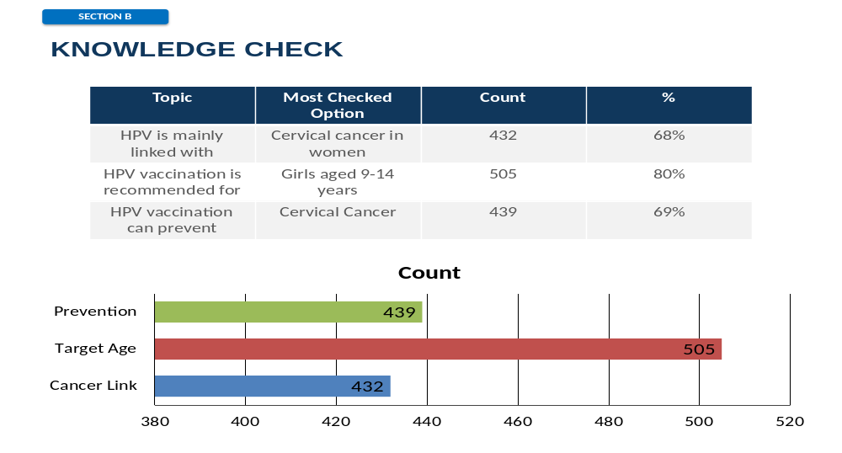
Figure 1: Knowledge check.
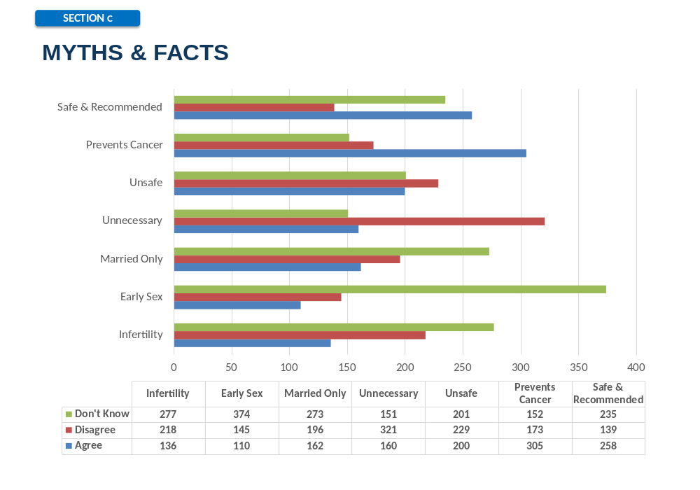
Figure 2: Myths and Facts.
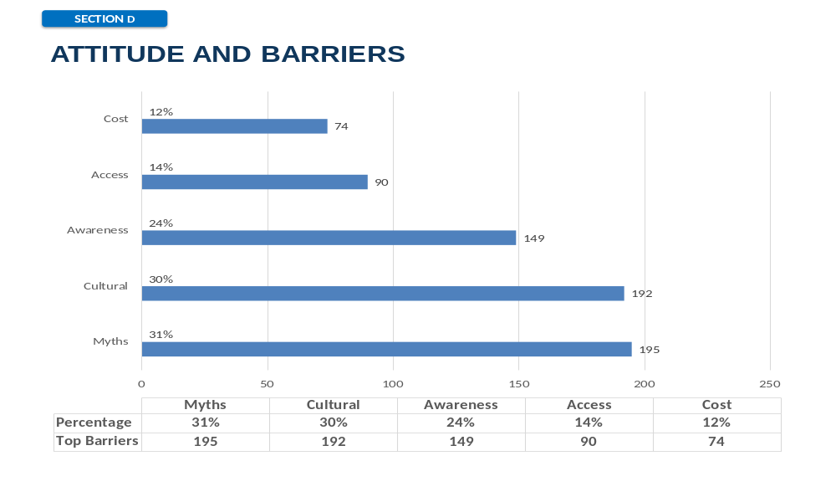
Figure 3: Attitude Barrier.

The figure 1 outlines the knowledge check of the participants. The figure 2 outlines the myths and facts among participants. Most of the participants recommended and didn’t show any concern about its safety. The figure 3 outlines the attitude barrier among participants. Myths is the top most barrier among participants and cost of the HPV is the least important fact.

TOP 10 MOST ASKED QUESTIONS
- What is the reason of HPV? - 31 times
- What are the side effects of HPV? - 27 times
- Can girls of my age get HPV? - 25 times
- Where can we get HPV from? - 24 times
- Is it compulsory to get vaccinated? - 24 times
- Is HPV caused by uncleanliness? - 23 times
- How many doses do we need? - 23 times
- How does HPV spread? - 22 times
- Can this vaccine make me weak? - 22 times
- What are the ways of spread of virus? - 21 times

Discussion
This study was conducted to assess the knowledge, perceptions and misconceptions of Human papilloma virus (HPV) infection and vaccination among teenage Pakistani girls. Our findings showed that a moderate number of participants (57%) knew about this infection and its vaccination. However, a considerable number of girls lacked understanding about the transmission of the virus, prevention and details about the vaccine. This pattern of limited awareness mirrors findings from recent studies conducted among adolescents in other developing countries.¹¹
While most participants were aware of HPV as a cause of cervical cancer, their knowledge about other aspects of infection was limited. This indicates that a broader understanding of disease transmission, nature of disease and oncogenic potential of the virus is lacking and most of the awareness is confined to widely publicized messages. Again, a similar pattern has been documented in recent studies carried by Alghalyini B et al. and Emon HH et al. where adolescents demonstrated a lack conceptual clarity regarding HPV.^{10,14}
Encouragingly, many girls correctly identified the approved age for HPV vaccination and its role in preventing cervical cancer. This shows that information about HPV and public health awareness regarding vaccination is reaching this population to some degree. However, still confusion persists among the participants as quite a few of them linked the vaccine to unrelated conditions or remained uncertain about its efficacy. Such discrepancies have been highlighted in current literature.¹⁵
A crucial insight of this study is the high incidence of misconceptions and uncertainty. A substantial number of participants opted for “don’t know” responses for several statements, especially those related to infertility, early sexual activity, and vaccine safety. Misconceptions such as HPV being associated with infertility or concerns about vaccine safety were also reported. These results align with research conducted by Singh et al. and other recent studies showing that misinformation and lack of accurate knowledge continue to be primary contributors to vaccine hesitancy.^{12,16}
The evaluation of barriers further underscores the role of sociocultural factors. The most significant barriers were myths and cultural beliefs followed by factors such as cost and access issues. This indicates that in this scenario social perceptions and stigma may have play a more pivotal role than logistical constraints. Similar findings have been reported in recent researches conducted in developing countries which identified factors such as cultural sensitivities and lack of open dialogue about reproductive health as significant factors affecting HPV vaccine acceptance.^{17,18}
In this study, the participants showed varied attitudes toward HPV vaccination, with a significant number of girls showing hesitation or uncertainty with regards to recommending the vaccine. Our study showed that there is a gap between awareness and acceptance. This further emphasizes that there is a complex interplay between knowledge, beliefs, and social influences. Previous research by Abdelhadi LM et al has shown that recommendations from healthcare practitioners, caregivers and trusted community figures significantly improve vaccine acceptance and uptake.^{13,19}
The feedback responses provided further insights into participants’ concerns and informational needs, with frequently asked questions addressing the cause of HPV, vaccine safety, eligibility, and modes of transmission. Our research work showed that there are many misconceptions among the participants particularly about HPV being caused by poor hygiene or fears regarding vaccine side effects. This reflects that there are gaps in basic health literacy. It is imperative to address these concerns through targeted, age-appropriate educational interventions as demonstrated in previous studies that showed improved awareness and acceptance following structured health education programs^{10,12}.
Overall, the findings of our study indicate that although adolescent girls in Pakistan are somewhat aware of HPV, there are significant gaps in accurate knowledge and perception. As there is a strong influence of myths and cultural beliefs in our society there is a dire need for structured educational interventions that are culturally sensitive as well. This can be achieved by changing school curricula to include HPV education and encouraging open discussions, as well as launching awareness campaigns through healthcare professionals. These steps could significantly improve knowledge about HPV among young people and increase vaccine acceptance.^{12,20}
As with other studies, ours has some limitations. As it was carried out in a selected group of adolescent girls, our findings cannot be generalized to the entire population. Additionally, since it was self-assessed data there is a possibility of response bias or misunderstanding of some of the questions. Lastly, as this was a cross-sectional study causal relationship could not be established. Despite these limitations, the study provides valuable information about awareness, perceptions and misconceptions about HPV vaccination among teenage girls.
Considering that our study group comprised mostly of adolescent girls, early intervention is crucial. Research shows that educating individuals from a younger age can have long-term effects in decision making and health related behaviors. Therefore, carrying out targeted educational programs at the school level could play a crucial role in reducing misconceptions and improving awareness about HPV and HPV vaccination rates in Pakistan.

Ethical Approval: The IRB/EC approved this study via letter no. IRB/2025/1826/SIMS dated May 23, 2025.
Conflict of Interest: None
Funding Source: None
Authors’ Contribution
FK: Conception.
AS, MAK: Design of the work.
AOA, MW, MN: Data acquisition, analysis, or interpretation.
FK, AOA, MW, MN: Draft the work.
AS, MAK: Review critically for important intellectual content.
All authors approve the version to be published.
All authors agree to be accountable for all aspects of the work.

References
- World Health Organization. Human papillomavirus (HPV) and cancer .Geneva: World Health Organization; 2024 Mar 5 [cited 2026 May 6]. Available from: [https://www.who.int/news-room/fact-sheets/detail/human-papilloma-virus-and-cancer]
- Forman D, de Martel C, Lacey CJ, Soerjomataram I, Lortet-Tieulent J, Bruni L, et al. Global burden of human papillomavirus and related diseases. Vaccine. 2012;30(Suppl 5):F12–F23.
- Centers for Disease Control and Prevention. Human papillomavirus (HPV): transmission. Atlanta: Centers for Disease Control and Prevention; 2024. Available from: [https://www.cdc.gov/hpv/parents/about-hpv.html]
- History of HPV vaccines and screening. STO Online; [cited 2026 May 6]. Available from: [https://so to-online.org/harmony/history-of-hpv-vaccines-and-screening/]
- Action C.C. Global progress in HPV vaccination. 2015 [cited 2016 Jun 14]. Available from: [http://www.cervicalcanceraction.org/comments/comments3.php]
- World Health Organization. Comprehensive cervical cancer prevention and control: a healthier future for girls and women [Internet]. Geneva: World Health Organization; 2013 [cited 2026 May 6]. Available from: [https://www.who.int/publications/i/item/9789241505147]
- ICO/IARC Information Centre on HPV and Cancer. Human papillomavirus and related diseases in Pakistan: summary report 2015. Barcelona: ICO/IARC Information Centre on HPV and Cancer; 2015. Available from: [https://hpvcentre.net/statistics/reports/PAK.pdf]
- Khan S, Jaffer NN, Khan MN, Rai MA, Shafiq M, Saba N, et al. Human papillomavirus subtype 16 is common in Pakistani women with cervical carcinoma. Int J Infect Dis. 2007;11(4):313–7.
- Shamsi U, Zahid F, Jabbar ABA, Musharraf MD, Gauhar F, Akbar I, et al. Human papillomavirus vaccine awareness and acceptability for primary prevention of cervical cancer in Pakistan: a cross-sectional study. Asian Pac J Cancer Prev. 2024;25(3):813–20.
- Alghalyini B, Zaidi ARZ, Meo SA, Faroog Z, Rashid M, Alyousef SS, et al. Awareness and knowledge of human papillomavirus, vaccine acceptability and cervical cancer among college students in Saudi Arabia. Hum Vaccin Immunother. 2024;20(1):2403844.
- Dewan M, Shukla D, Shrivastav G, Diwan P. Knowledge and attitude towards HPV infection, HPV vaccination and cervical cancer among middle- and high-school students in Gwalior. J Family Med Prim Care. 2024;13(10):4382–7.
- Singh A, Dandekar SP, Dhumale GB, Khairnar MR. Effect of health education on the knowledge and attitude regarding the human papillomavirus vaccine among adolescent school girls of a city in western Maharashtra. Indian J Community Health. 2024;36(3):2822.
- Abdelhadi LM, Aryan FS, Alsabi R, Samhan GA, Al-Qaaneh AM. Knowledge, attitudes, and practices associated with human papillomavirus vaccine recommendation among healthcare professionals: a cross-sectional study. Infect Dis Rep. 2025;17(5):126.
- Emon HH, Kowbi RN, Chowdhury MN, Teep TR, Habib MA, Tayeeba F, et al. Assessing knowledge, attitudes, and barriers toward HPV cervical cancer and vaccination among female university students in Bangladesh. Sci Rep. 2025;15(1):44529.
- Rakheja S, Mehta D, Aggarwal I, Goel H, Joseph D, Jain J, et al. Knowledge, attitude and awareness of HPV vaccination among college-going girls (18–26 years) in Delhi NCR. Asian Pac J Cancer Nurs. 2025; doi:10.31557/apjcn.1967.20250806.
- Hristamyan M, Rangelova V, Lolovski T, Homadi M, Kevorkyan A. Study of the knowledge, attitudes and practices of students from medical majors regarding HPV infections and HPV vaccines. Pathogens. 2025; 14(12):1270.
- Atif N, Hashmi FK, Malik UR, Ghauri MA, Gillani AH, Kadirhaz M, et al. From awareness to acceptance: understanding HPV and vaccine knowledge, attitudes and beliefs among university students in Punjab, Pakistan. J Pharm Policy Pract. 2025;18(1):2473023.
- Zheng S, Deng X, Li L, Luo F, He H, Wang Y, Xu X, Wang S, Chen Y. Awareness, preference, and acceptance of HPV vaccine and related influencing factors among guardians of adolescent girls in China: a health belief model-based cross-sectional study. Vaccines (Basel). 2025;13(8):840.
- Li W, Jin Y, Li X, et al. Human papillomavirus and vaccine knowledge, willingness, and uptake among university students: a systematic review and meta-analysis. BMC Public Health. 2025;25(1):4268.
- Akhter N, Nasrin S. Knowledge, practice and awareness of adolescent girls on human papillomavirus vaccine. Int J Reprod Contracept Obstet Gynecol. 2025;14(2):426–30.

